


Anguilla Maritime Administration
& Shipping Registry

AMASR

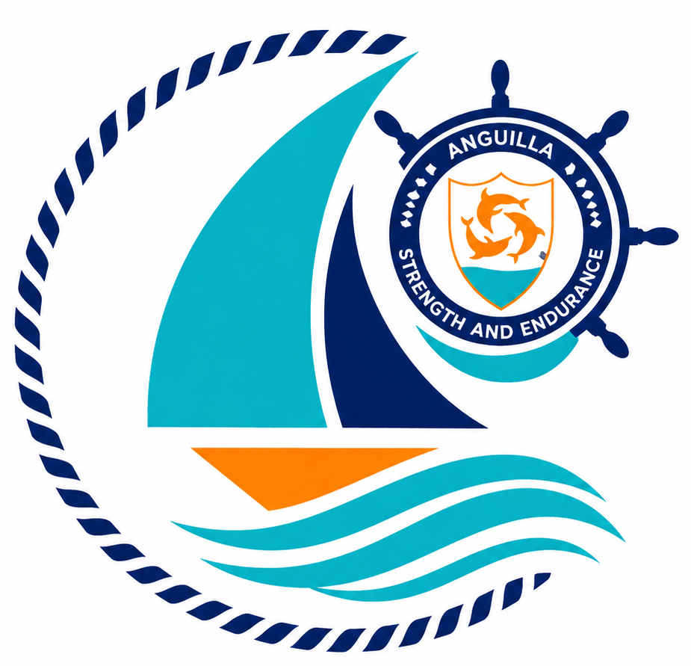

Form: | Appointment of Anguilla Resident Agent
No.: | 02
Rev.: | 00
Date: | 2026-06-10
To: | Recognized Organizations, Shipowners, Managers, Masters, Seafarers, Partners, Brokers, Surveyors, and the general public.

Strength and Endurance

Address: Anguilla Maritime Administration
Anguilla, Leeward Islands, Ministry of Infrastructure, Communications, Utilities and Housing, Coronation Avenue, The Valley Anguilla
Tel: +447454760022| Email: info@amasr.ai

FORM 02 - APPOINTMENT OF ANGUILLA RESIDENT AGENT

Please complete this form electronically or in block capitals using black ink.

1. Vessel details
Vessel name
Vessel type
IMO Number
2. Ownership details (foreign individual or company)
Full Name
Address
Telephone n. |  |  |  |  | Fax n.
Email
3. Appointment by the owner
I hereby declare that the appointed Anguilla Resident Agent in section 4, at the indicated address for service, is authorised to transmit all correspondence to and from the Maritime Authority of the Anguilla in respect to the above vessel.
Date |  |  |  | Role
Name of applicant |  |  |  | Signature of applicant
4. Details of Anguilla Resident Agent
Name
Address for service
Telephone n.
Email
ISS Code
Economic Operator Code
5. Declaration by the appointed Anguilla Resident Agent
I hereby declare that I accept the appointment and shall transmit all correspondence, notices and notifications to and from the Maritime Authority of the Anguilla on behalf of the applicant.
Date
Name of Applicant |  |  |  | Signature

Note: Refer also to the guidance notes overleaf.

- Foreign residents or companies of another State qualify to hold ownership of a vessel registered in Anguilla after electing domicile with an agent residing or legally established in Anguilla.
- This application must be signed by the beneficial owner, company director, or authorized representative holding a power of attorney.
- The nominated resident agent will act as the representative of the owner for all necessary correspondence for the registration of the ship and any other services necessary for flying the Anguilla Flag in accordance with the Maritime Authority of Anguilla laws and regulation. The resident agent will be responsible to transmit to the owner any notifications from the AMASR.
- Should the resident agent resign from this position, the AMASR shall be informed immediately. The Certificate of Registry could be revoked if an application nominating a new representative is not submitted by the registered owner.

